## Student 1 Name: Michael Kelly

## Student 1 ID: s00153921

## Student 2 Name: Adam Lee

## Student 2 ID: s00174787

## Programme: Web Programming 3

## Submission Date: 11/12/16

# Overview

We want to design and build a website that will give our users a simple yet effective way to purchase tickets online and receive the latest news of events and other information all in one website. We would like to offer our users the opportunity to create an account for purchasing tickets for events all over Ireland and keep track of the news coming up to these events. There will also be artist bios and news on upcoming events for all artists, also previous event details we maybe include a comments section so user who hold accounts with us can leave comments on the event if they attended and how their experience was at the event. We are aiming for a visual website but we aim to keep it simple for easy navigation and quick purchases. We have added an events planner section as to not cause any confusion for regular customer registration but login for customer, event planner and administration is all from the one login page.

# Research

## Similar Systems

**Ticketmaster-** Ticket sales, user ability to select favourites from a list of categories, login to the site to access their previous bought tickets and upcoming events that they might like.

**Tickes.ie-** The user will have the ability to search for music or browse through a page with categories, the user will also be able to do a search for tickets based on the person they are wishing to acquire tickets for.

**Ticketbooth-** The user will be able to browse through a gallery of images based on the selected event, the user will also be able to post reviews and view other reviews before buying a ticket.

**Ticketofficesales-** The user will be able to keep up to date with a news feed that will tell them if an event has been cancelled or there has been a time change.

## Technologies

**Bootstrap-** for the responsiveness of the site.

**Visual studio-** for the code editor, Database design and the CSS design.

**Stripe-** this will be used for the payment methods.

**PayPal-** If users would like to use PayPal to make payments we also offer this option.

**Ticketmaster- <MICHAEL>**

# Design and User Interface

## User Interface

From the wire frames the design of the website can be seen even back in the early stages of development. Although many features were added or removed the only feature that was never used in the header were the social media icons, we realised early on that placing the icons in the header would take up essential space that we required for navigation.

## 

## E:\Year 3\WebProgramming3\Assign1Document\IMG_0563.JPG

At the current version of the website we felt it was unnecessary to have profile pictures as there is no profile to profile communication although with more time we would like to incorporate this feature into our website to allow our users to buy, sell and trade tickets directly form out website.

## E:\Year 3\WebProgramming3\Assign1Document\IMG_0564.JPG

The contact us page is almost identical to the wireframes and was all was intended to be simple and easy to use and navigate to.

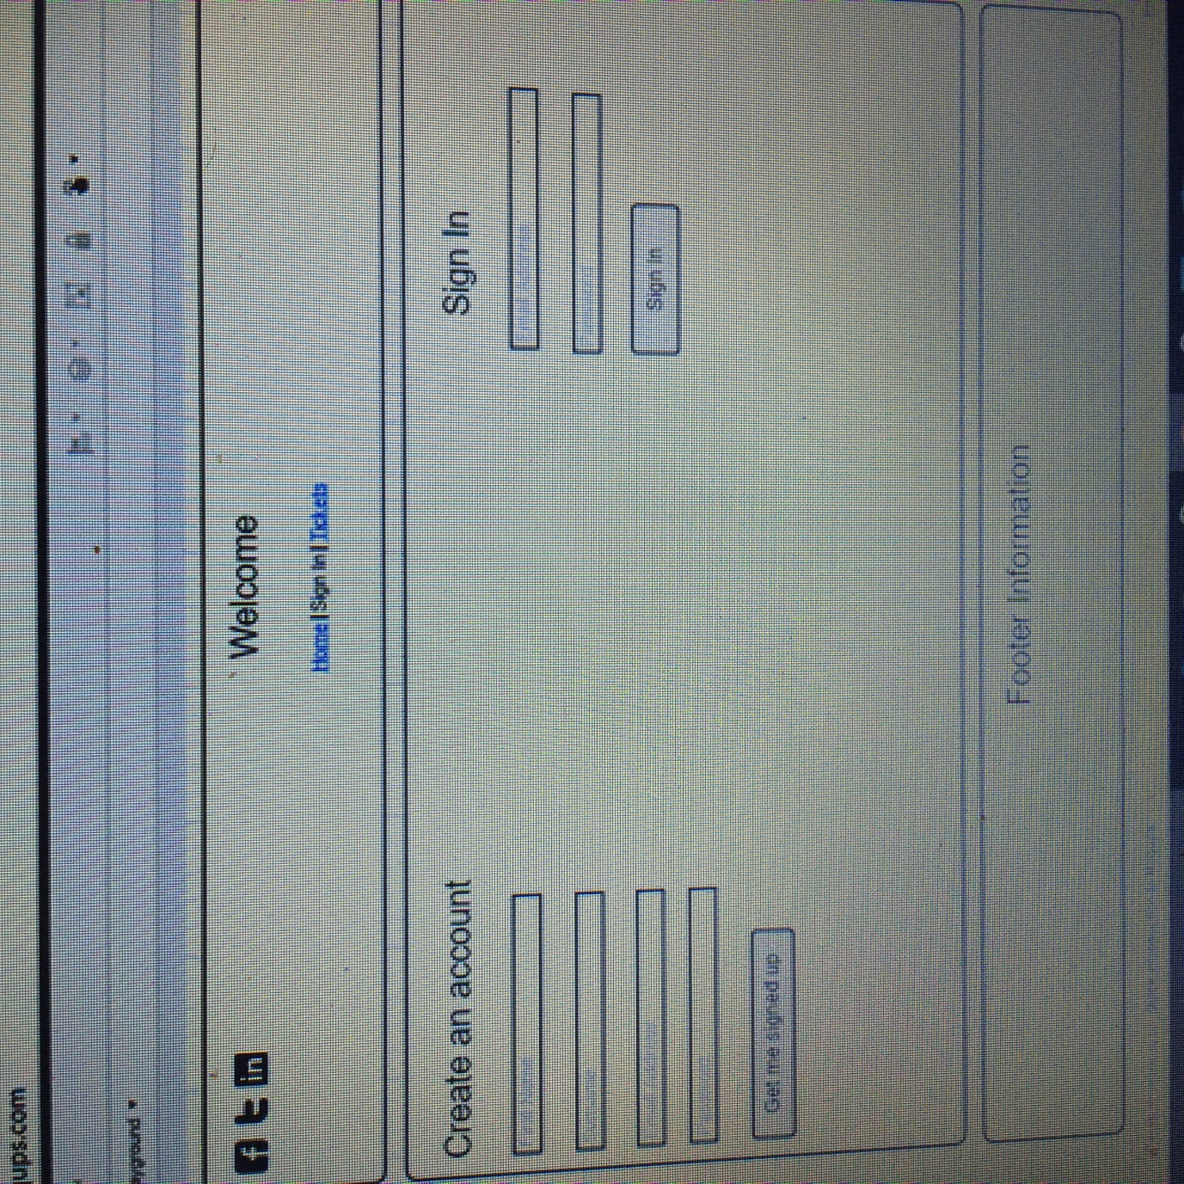

To avoid confusion, we divided this page into three separate pages, the log in, customer registration and event planner registration. The design has stayed identical to the wireframes from the early development stages.

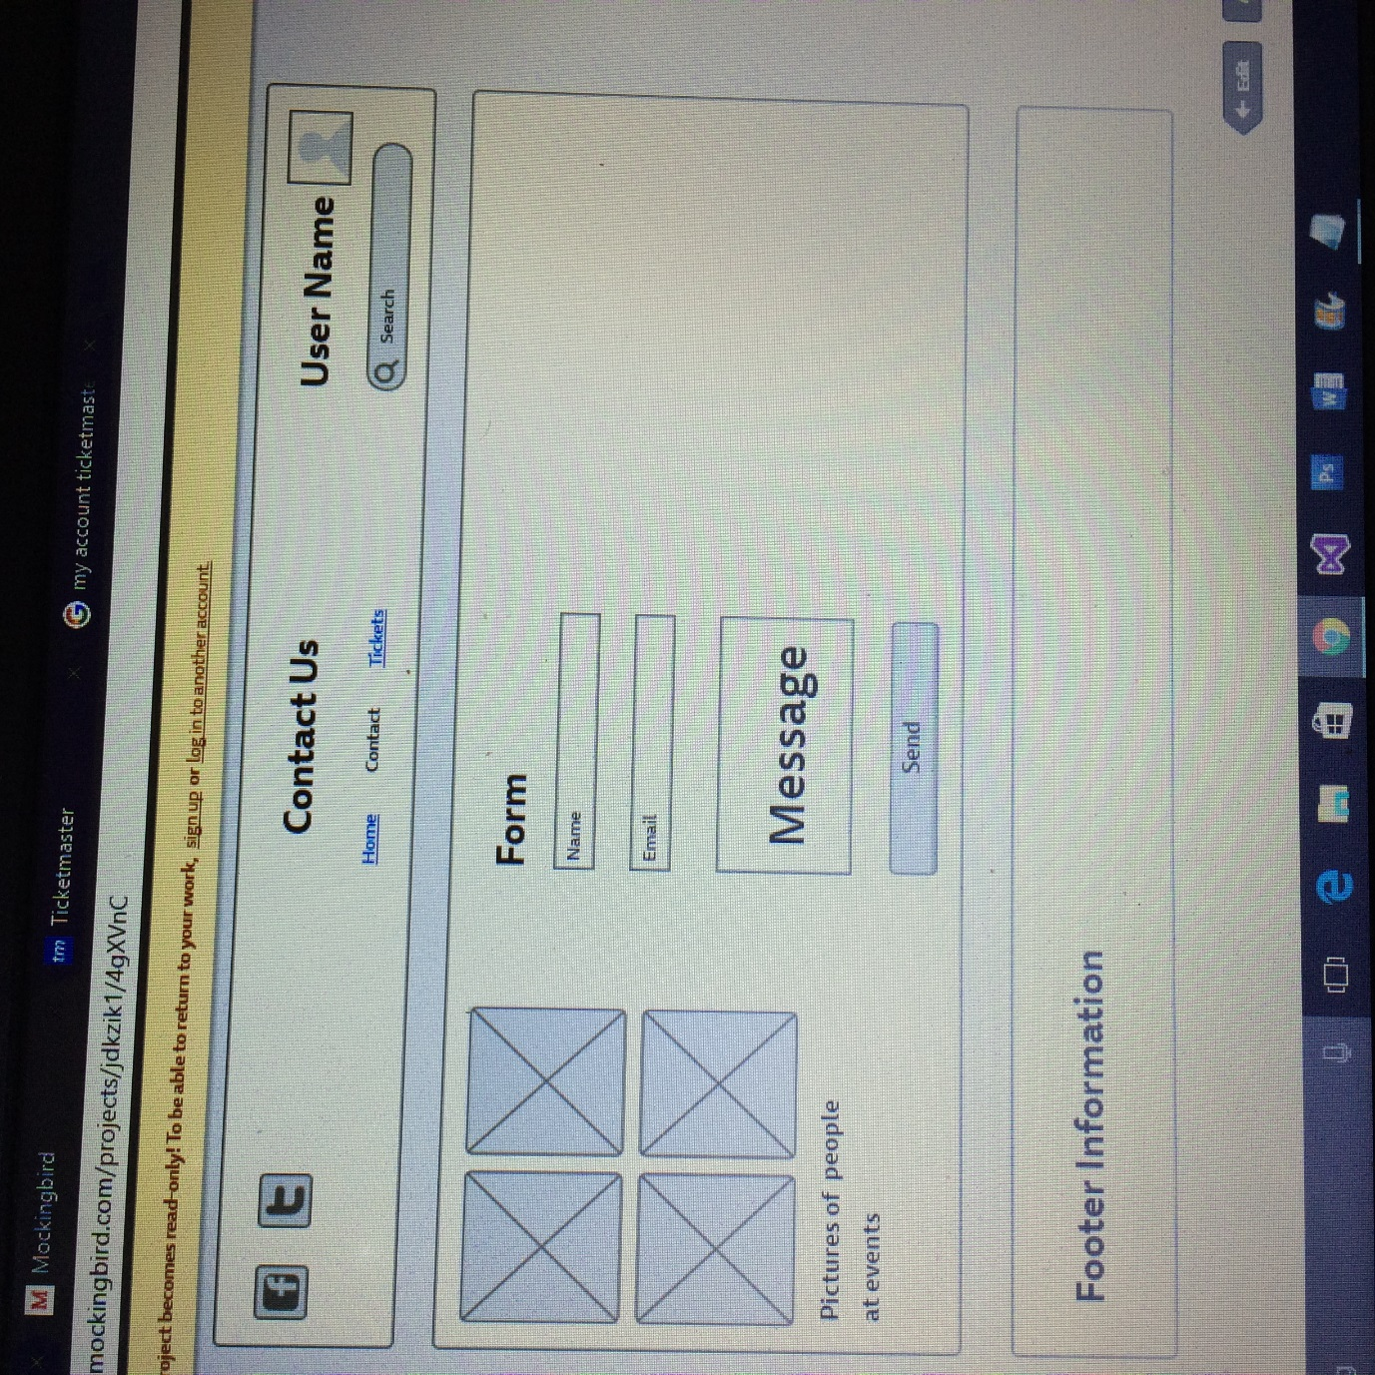

## Overall Architecture

C:\Users\adaml\AppData\Local\Microsoft\Windows\INetCacheContent.Word\Web3SiteMap.png

The site map above is the final version of the sitemap we have decided to stay with the design as it is simple, easy to navigate. If there is time towards the end of the project more pages may be added to give a more realistic view of what we would like the website to look like if we had more time for development. The webpages will include data pulled directly from the database and will update when tickets are sold out or new dates for events have been added etc.

The site map account section (the yellow section of the sitemap) as changed slightly as we split up the registration page and gave separate log in pages for customers and event planners to avoid any confusion among users.